Transportation map
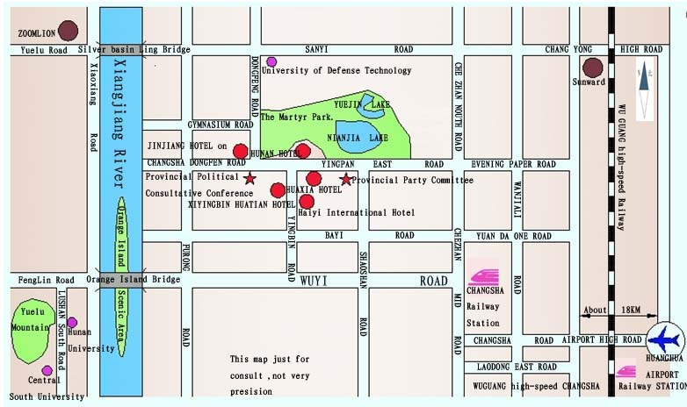
Route 1：take the Airbus
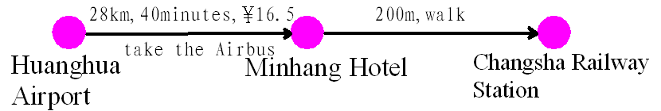
Route 2：take a taxi
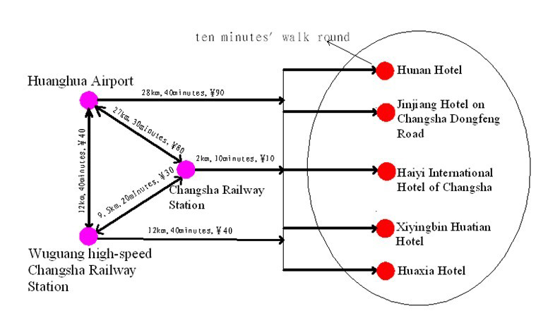
Traffic Advisory： Teacher zhang：13397617684 Teacher lu ：13787012635

