湖 南 宾 馆 简 介

湖南宾馆始建于1959年，1962年正式对外营业，是湖南省历史上最早、知名度和美誉度都很高的宾馆，五十年来深受国内外宾客的好评。
自建馆以来，湖宾一直是省委、省政府接待客人的主要单位，是接待过陈毅、王震、叶剑英、胡耀邦、江泽民等党和国家领导人及西哈努克亲王、尼泊尔首相等外国元首和政要的地方。从1962年起至2009年，接待了每届中国共产党湖南省代表大会。每年都接待了省人大会或省政协会。共接待过全国和省内各种会议一万多个。1986年确定为省政府的接待宾馆，直属省政府办公厅领导，平均每年要接待省部级领导一百多批
宾馆位于烈士公园东侧，与省委毗邻。院内环境幽雅、绿树成荫，是花园式单位、公园式宾馆；庭院宽敞，可同时停放小汽车400多台；交通便利，距火车站约1.6公里，距黄花机场26公里，距繁华的五一路、芙蓉路仅一箭之遥。
在刚刚过去的2009年是不平凡的一年，宾馆经历了五十年的风雨兼程，在湖宾人的共同努力下，不仅顺利完成了宾馆全年任务，而且能经得起考验；在2009年被评为四星级宾馆。
宾馆2008年重新装修后,硬件档次达到四星级,宾馆经营和管理按四星级标准运作.宾馆有两栋客房，主楼雄伟气派，客房空间大、面积宽（层高4米，标准间面积达20多平方米），居住舒适，长期以来得到了客人的一致认可和好评。三号楼为别墅式建筑，室内装饰豪华典雅，客房内配有健身设施。全馆有高、中档客房359间，床位645个，有大小会议室36个，各种格调高雅、装饰豪华气派的餐厅32个，可同时容纳1800人就餐。
湖南宾馆将始终以客人满意为宗旨，与时俱进，以一流的环境、一流的设施、一流的服务恭候着海内外宾客的光临！

Introduction of Hunan Hotel
Hunan Hotel was set up in 1959, opened in 1962, the earliest Guest House in Hunan. It has been praised by the domestic and foreign guests for its high popularity and reputation in fifty years.
Since it was set up, the Hotel has been a major reception house of Hunan Provincial Party committee and Provincial Government. It has received such State and Party leaders as Chen Yi, Wang Zhen, Ye Jianying, Hu Yaobang, Jiang Zemin and also many foreign state heads and VIPs: Prince Sihanouk, Prime Minister of Nepal, and so on. From 1962 to 2009, the Hotel has received a variety of meetings up to over 10 thousand, such as each Hunan Provincial Congress of the Communist Party of China, Provincial People's Congress and Provincial Political Consultative Conference. In 1986, the Hotel was nominated as the Provincial Government Reception House, directly under the leadership of the Provincial Government Office. Every year the Hotel receives more than 100 groups of provincial and ministerial leaders averagely.
Hunan Hotel is located on the East of Ying Pan Road 193, by the side of the beautiful Changsha Martyrs’ Park, and adjacent to the court- yard of the Hunan Provincial Party Committee. Because of its quiet, elegant and tree-lined environment, it is a garden or park hotel; its spacious courtyard, it can park over 400 cars; its convenience, the hotel is easily accessible by all types of public transports, 5 minutes drive from Changsha Railway station, 30 minutes drive from Huanghua International Airport, and also very close to the busiest streets Wuyi Road and Furong Road.
After renovation in 2008, facilities ,operation and management of the hotel basically achieves the Four-star standard. The Hotel has two guest room buildings. The chief building is grand and magnificent, with large and wide room space (4 meters high, and more than 20 square meters for standard rooms ). It receives guests recognition and praise for its comfortable living for a long time. The other building, which is called No.3 Building, is a villa-style building with luxurious and elegant interior decoration and fitness facilities in rooms. The Hotel offers 359 high, mid-range rooms, 645 beds, 36 large and small meeting rooms, 32 luxurious restaurants in all, which can admit over 1 800 guests to have dinner at the same time.
Hunan Hotel will always keep the purpose of guest and customer’s satisfaction, and keep pace with times. It welcomes friends from all over the world with its first- class environment, first-class facilities and first-class service.

房间价目表
房 型 | 门市价  元/间/晚 | 优惠价  元/间/晚 | 会议价  元/间/晚 | 房间面积
行政标准间 | 498 | 298 | 260（含早） | 27㎡
商务标准间 | 568 | 328 | 280（含早） | 27㎡
单 间 | 328 | 228 | 210（含早） | 18㎡

R O O M T A R I F F
ROOM TYPM | PRTCE  (RMB/PER NIGHT) | FAVORABLE PRICE  (RMB/PER NIGHT) | MEETING PACKAGE  (RMB/PER NIGHT) | ROOM AREA
STANDARD ROOM | RMB498 | RMB298 | RMB260（BREAKFAST） | 27㎡
BUSINESS ROOM | RMB568 | RMB328 | RMB280（BREAKFAST） | 27㎡
STNGLE ROOM | RMB328 | RMB228 | RMB210（BREAKFAST） | 18㎡

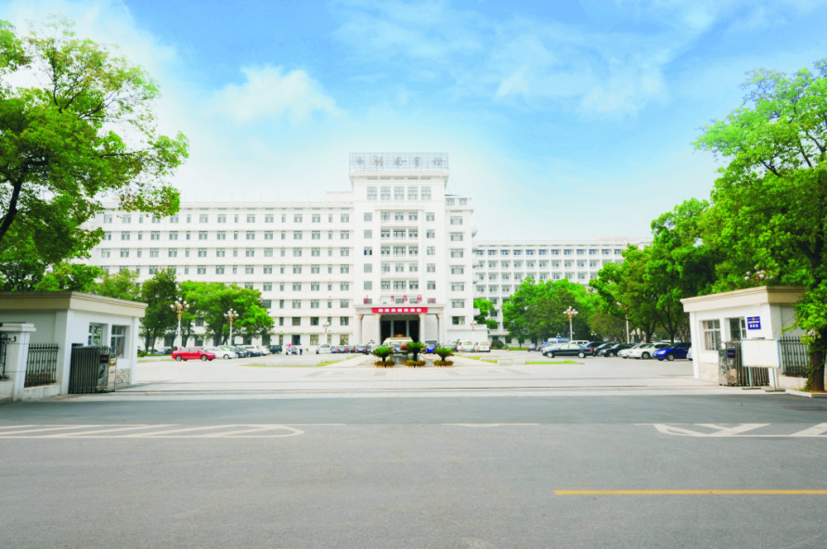 宾馆全景
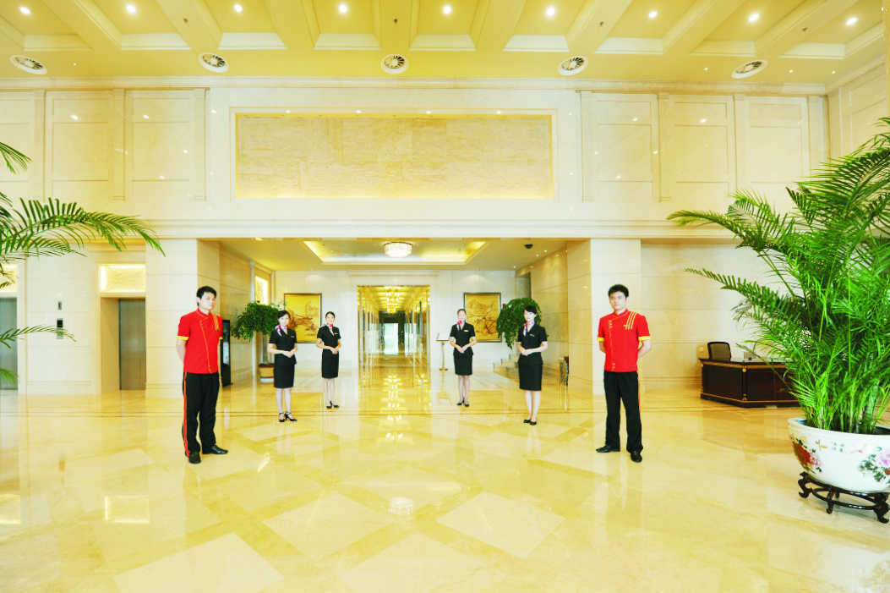 宾馆大堂

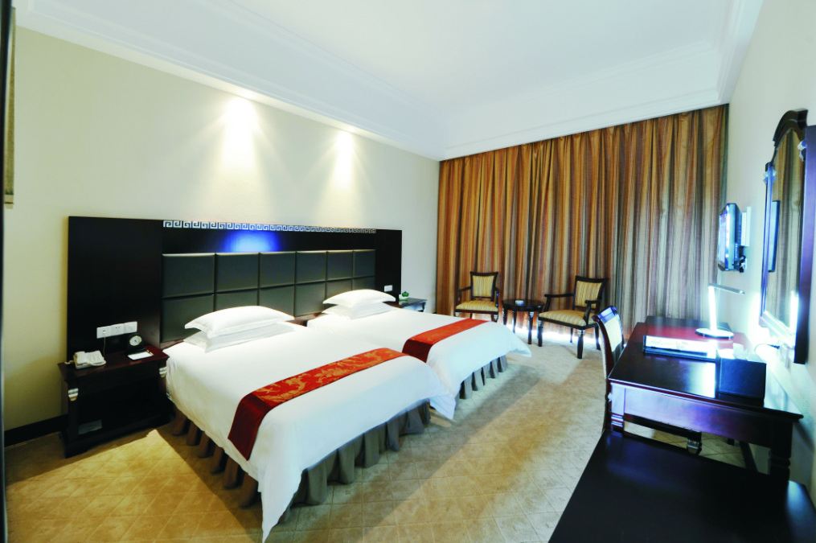 标准间
